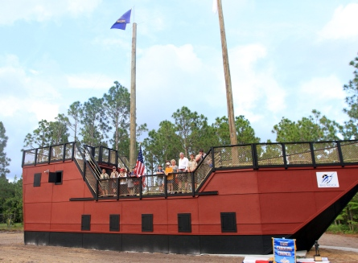

Scouts and family members stand on a three-story tall pirate ship that was dedicated Tuesday at Camp Sam Hatcher in Newport. The Big Rock Blue Marlin Tournament and the East Carolina Council of Boy Scouts of America had the ship constructed as a gathering place for campers

It’s designed as a gathering place and learning tool. But in the end, it’s just fun.
The East Carolina Council of the Boy Scouts of America dedicated the Big Rock Blue Marlin Pirate Ship during a ceremony Tuesday at Camp Sam Hatcher in Carteret County.
“It’s awesome,” Havelock Cub Scout Logan Lee, 7, said after exploring the three-story tall ship.
The fishing tournament provided a matching donation of money to the East Carolina Council to pay for the construction of the $160,000 ship. Since 1998, the charitable foundation of the fishing tournament has provided $175,000 in donations to the East Carolina Council, which governs Cub and Boy Scout troops in 20 Eastern North Carolina counties.
“Our goal every year is to put on a world class fishing tournament in Morehead City and in everything we do to put charity first, particularly for our young people,” Tommy Bennett, treasurer of the Big Rock Foundation, told the crowd during the dedication ceremony.
Bennett thanked Ben Moore, past council president, with bringing the project to the attention of the Big Rock.
“When Ben brought this project to us, it was a no-brainer situation,” said Bennett.
Bennett said he was involved in scouting as a youth and displayed a patch he received for attending winter camp at Sam Hatcher.
“I spent the coldest night of my life here,” he said. “It was eight degrees.”
He challenged the scouts to grab the reins of leadership.
“Remember this day when people you don’t even know and may never see again gave you this gift,” Bennett said. “I hope that as you grow older you’ll remember this so you will be the person to give back to your community.”
The ship has three cabins on the lower level that can be used for gatherings, while the deck of the ship, which has three levels, can be used as a play area as well as a stage for contests or other activities.
Skip Greene III, president of Group III Management in Kinston that constructed the ship, received the honor of christening the structure. After failing to break the bottle of champagne on the front of the ship, he simply bent down to crack it open on the concrete foundation.
Then it was time for the scouts in attendance to explore the ship.
I think that you can open and close the windows is the coolest part,” said 9-year-old Webelo Patrick Ashby.
He poked his head out of the window, waving to family members, and then went and opened the next window.
“I think it’s pretty cool,” Ashby said of the ship. “I’m really happy that it’s here.”

